CA2 Individual Report
Name | Navin Kuppa
Student Id | P2526487
Class | DIT/FT/1B/01
Github Repository URL | NAVIN255/bed-ca2-NAVIN255
Github Account ID | NAVIN255

For each competencies, find links to pull requests/commits/files that demonstrate the completion of the requirement. Replace each “?” with your Self Rating.
For Self Rating, you may rate yourself accordingly if you feel that you:
- Have little or no understanding. and did not attempt the requirement
- Have limited understanding of the specific competency
- Have basic understanding and only able to replicate examples from tutorials/practicals.
- Have adequate understanding and can extend from what you have learned to fulfil specifications.
- Have solid understanding in the specific competency, able work on the requirement without much references.
- Have excellent understanding and implemented the requirement according to latest industry guidelines, best practices and documentations.

Important
- You are require to provide for each competency:
  - A brief description
  - One or two of your best implementations with URL link to respective repository request/commits/files.
    - Below is an example of linking to specific script file
https://github.com/expressjs/express/blob/master/examples/static-files/index.js
  - The implementations may come from Section A or B.
- You are to ensure the hyperlink in this document works. Failure to do so will result in a 50% deduction of marks.
- You are to provide screenshots using POSTMAN to perform API test.

No. | Competencies | Describe What Was Done | Self Rating
1 | Backend Server | The backend server was built using Node.js with Express.js to handle incoming HTTP requests.  RESTful API routes were created to manage users, fitness challenges, spell activation, and challenge completion.  The server communicates with a MySQL database using mysql2 and returns structured JSON responses.  Middleware was used for authentication, validation, and request handling to ensure secure and controlled access. | 4/5
2 | Functionality | All core features were implemented according to the requirements, including user registration, login, challenge creation, challenge completion, skillpoint rewards, spell activation, and user profiles.  Gamification elements such as levels, badges, and spells enhanced user engagement.  Each feature was tested to ensure it fulfilled its intended purpose. | 4/5
3 | Code Quality | Code was written using clear naming conventions and consistent formatting.  Controllers, routes, models, and services were separated to improve readability.  Repeated logic was avoided and comments were added to explain complex logic. | 4/5
4 | Modularity | The project was organised into modules such as routes, controllers, models, middleware, and frontend services.  This modular structure allows easy maintenance, testing, and extension of features without affecting other parts of the application. | 5/5
5 | Error Handling | Errors were handled using HTTP status codes and meaningful error messages.  Backend validation checks for missing fields, invalid difficulty values, unauthorized access, and duplicate actions.  Frontend displays user-friendly alerts when errors occur | 4/5
6 | Documentation | Code comments were added to explain complex logic.  File and folder naming conventions improve understanding.  The GitHub repository contains a README explaining setup and usage. | 4/5
7 | JWT for Authentication | JWT was implemented for secure authentication.  Tokens are generated during login and verified using middleware before accessing protected routes.  Access tokens are stored in localStorage to allow users to remain logged in across sessions. | 5/5
8 | BCrypt for Password Hashing | User passwords are hashed using bcrypt before being stored in the database.  During login, entered passwords are compared with hashed values securely.  This ensures strong security while maintaining reasonable server performance. | 5/5
9 | Frontend to Backend HTTP Requests | Frontend communicates with the backend using Fetch API through a centralized APIService class.  Authenticated requests automatically attach JWT tokens.  This abstraction simplifies API usage across the frontend. | 5/5
10 | HTML & CSS Proficiency | Responsive and structured layouts were built using semantic HTML.  A custom magical-theme.css was created with CSS variables, animations, gradients, and responsive design.  Components such as cards, modals, dashboards, and forms are visually consistent and user-friendly. | 5/5
12 | JavaScript and DOM Manipulation | JavaScript dynamically updates the DOM based on API responses.  Challenges, spells, stats, and user profiles are rendered dynamically.  Event listeners handle form submissions, navigation, and user actions. | 5/5

Updated Entity Relationship Diagram
ERD
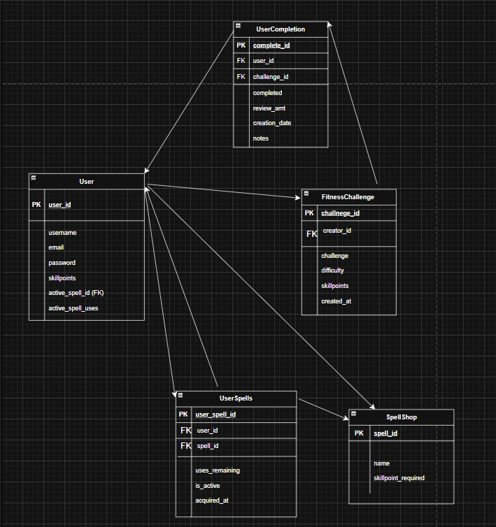

Video Demo
No. | Label | Screenshot
1 | BED CA2 web | https://youtu.be/RJWi2WN5ozs

